abstract
accepted for presentation
at the 1999 NASPE
Toronto
May 13-15, 1999
PACE, Vol. 22
No. 4, Part II,
Page 767

T Wave Alternans Predicts Arrhythmia Vulnerability in Patients with Ischemic Cardiomyopathy
Karen S. MacMurdy, MD, Stephen R. Shorofsky, MD, PhD, Mary R. Olsovsky, MD, Michael R. Gold, MD, PhD, University of Maryland, Baltimore, MD

T wave alternans (TWA) is a noninvasive predictor of arrhythmia vulnerability. However, it is unknown if TWA predicts spontaneous ventricular arrhythmias in populations at high risk for sudden death.

Methods: This was a prospective evaluation of 87 consecutive patients (pts) with ischemic heart disease, ejection fraction (EF) < 40% and in sinus rhythm referred for electrophysiology testing. TWA was measured during pacing or exercise to achieve a heart rate > 105 bpm, as was classified as abnormal (TWA+) by standard criteria. An event was defined prospectively as sustained VT, cardiac arrest, appropriate defibrillator therapy or death.

Results: This population was 78% male, 65 +10 years old with an EF of 27 +8%. There were no demographic differences between TWA- (n=23) and TWA + (n=64) pats. There were 3 events (13%) in the TWA- group and 21 events (31%) in the TWA+ group (P<0.05). Kaplan-Meier analysis demonstrated improved event-free survival in the TWA- group (p=0.03), with a relative risk of 3.5.

Conclusion: TWA is a strong independent predictor of arrhythmia vulnerability in pts with ischemic cardiomyopathy.
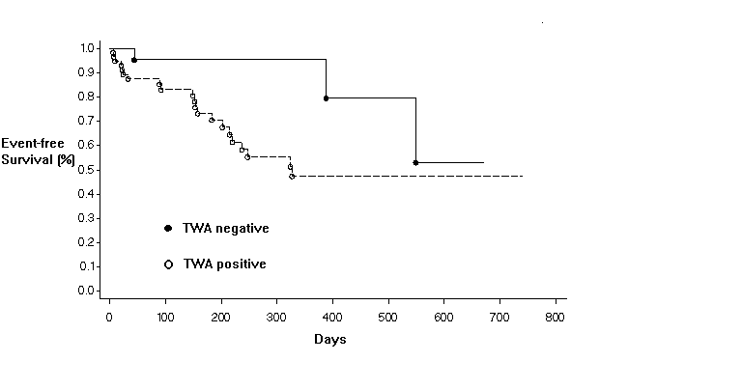

1 Oak Park Drive
Bedford, MA 01730
781-271-1200

